
FATIMA JINNAH WOMEN UNIVERSITY
RAWALPINDI
Department Of Software Engineering

Cloud Computing Lab
Saira Ejaz [2023-BSE-057] Section: 5-B LAB NO 4
Lab Task:

Task 1 – Verify VM resources in VMware Steps
- Open VMware Workstation and locate the Ubuntu Server VM you used in Lab 1.
- Inspect VM settings and note the following (no commands required for GUI): VM name, RAM, CPU, disk, and network adapter type
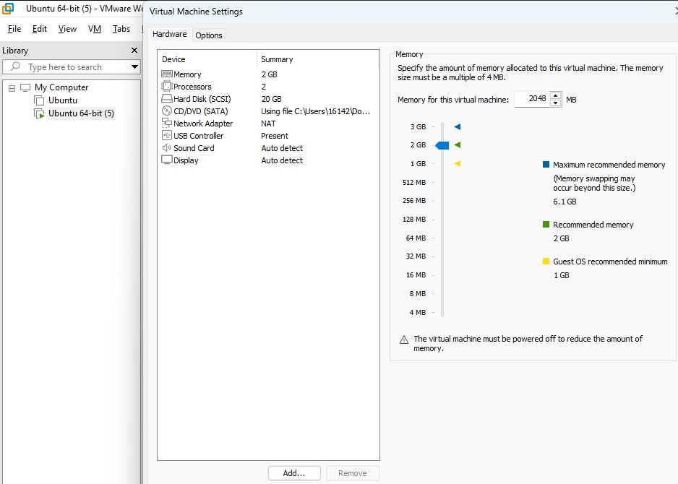

Task 2 – Start VM and log in (use your preferred host terminal method only)
Use a single preferred host-terminal method to connect to the VM. Do not switch between methods during the task.

Steps
- Start (or resume) the VM in VMware Workstation on your host.
- From your host, open your preferred terminal (for example: Windows Command Prompt, PowerShell, macOS Terminal, or Linux Terminal) and connect to the VM using SSH.
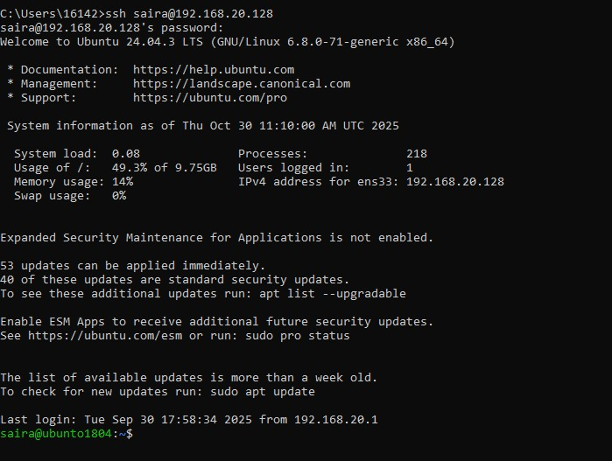
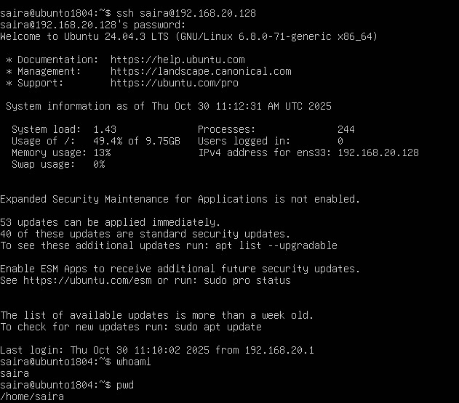

Task 3 – Filesystem exploration — root tree and dotfiles
Explore Linux filesystem layout and hidden files. Capture outputs using screenshots only (do not create text files). For the short explanation required in this task, write the paragraph in an editor and capture it as a screenshot (answers_md.png) — do not supply the .md file.
- List root directory contents:
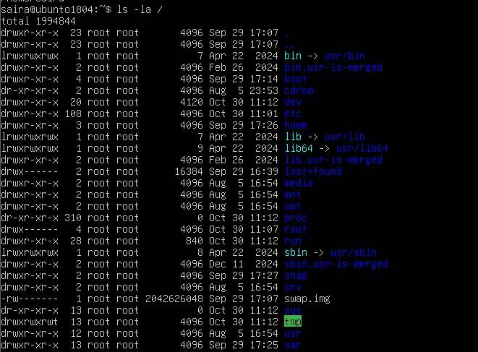
- Inspect these directories (run each command and screenshot the output)
ls -la /bin
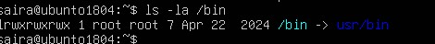
ls -la /sbin
ls –la /usr
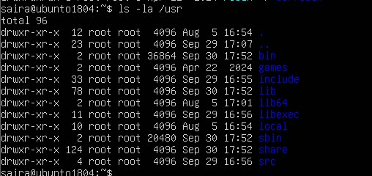
ls -la /opt
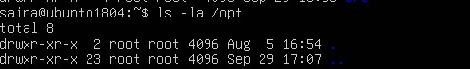
ls -la /etc
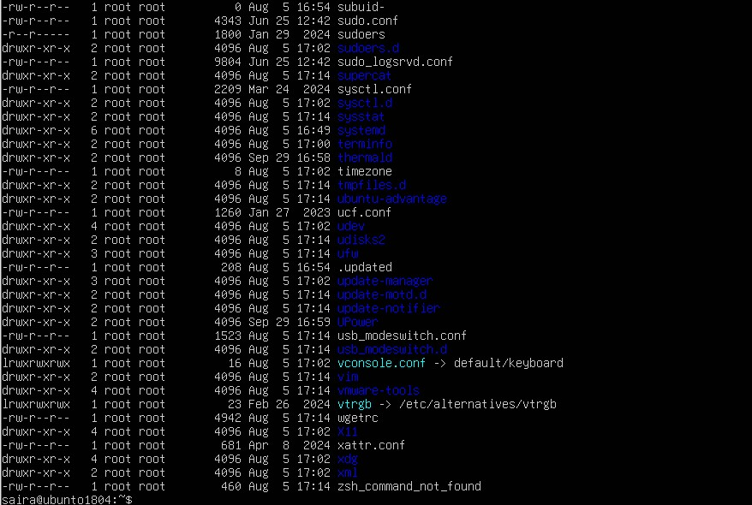
ls -la /dev
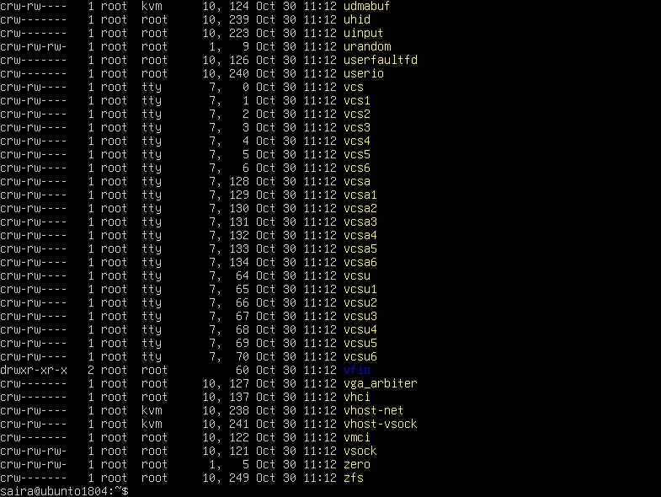
ls -la /var
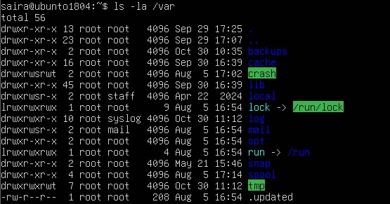
ls -la /tmp
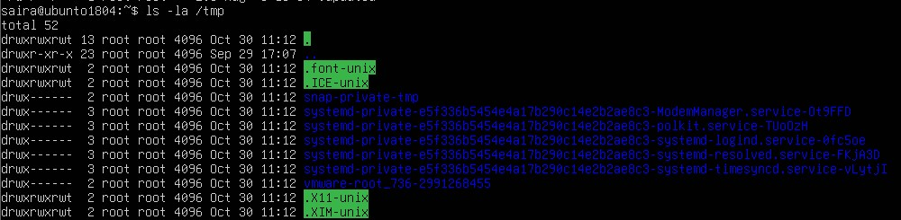
ls –la
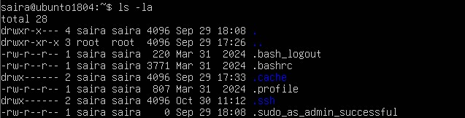
nano ~/answers.md
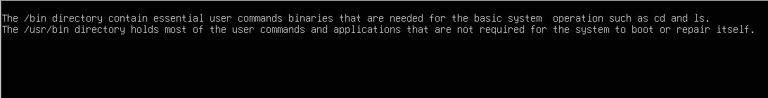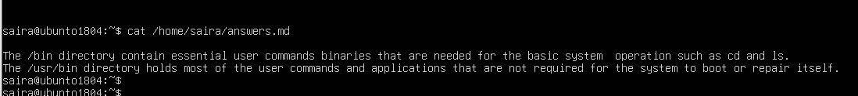

Task 4 – Essential CLI tasks — navigation and file operations
Practice basic commands used daily on Linux systems. Use screenshots only for evidence.

1. Create a workspace and navigate: mkdir -p ~/lab4/workspace/python_project cd ~/lab4/workspace/python_project
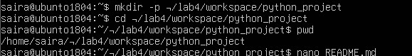
2. Create files using an editor (open each editor session and save a screenshot showing content):

nano README.md
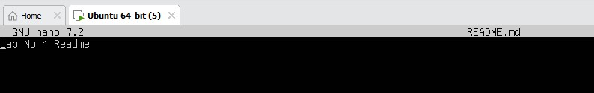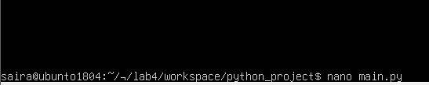

nano main.py
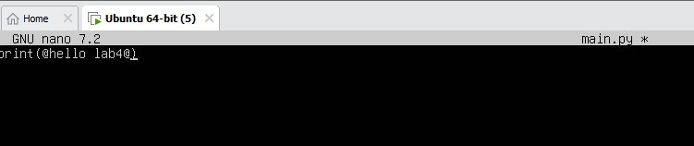
nano .env

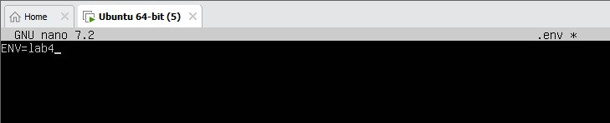 ls –la
3. Copy, move and remove:

cp README.md README.copy.md
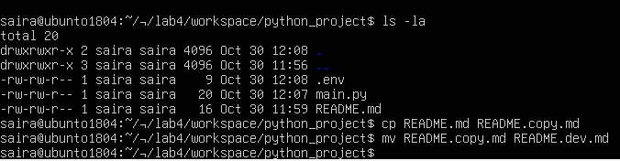

rm README.dev.md mkdir -p ~/lab4/workspace/java_app cp -r ~/lab4/workspace/python_project ~/lab4/workspace/java_app_copy ls -la ~/lab4/workspace
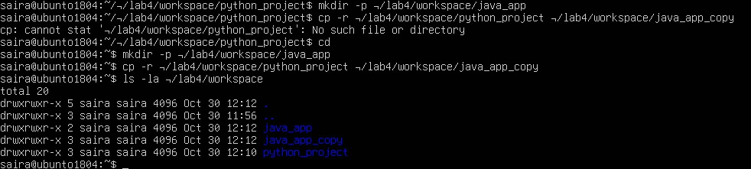

history
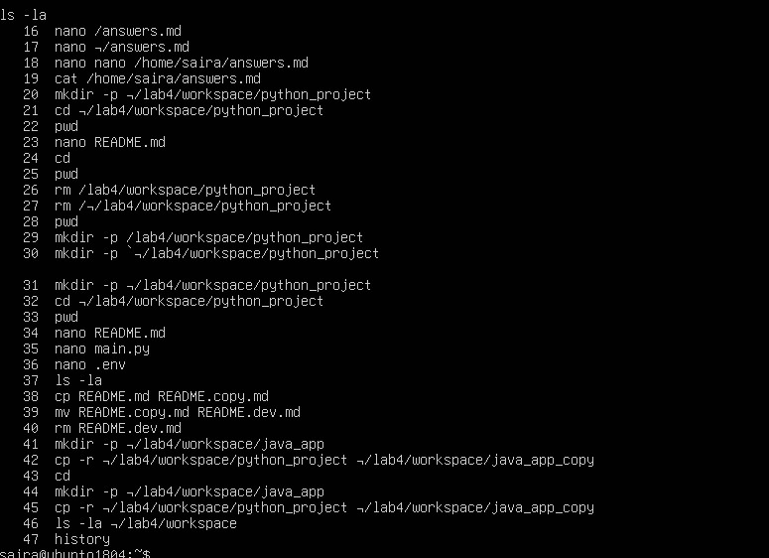
Task 5 – System info, resources & processes
Collect system information and observe processes. Use screenshots only.

Steps (inside VM terminal)
1. Kernel and OS:

uname –a
2. CPU (ensure model name visible):

cat /proc/cpuinfo
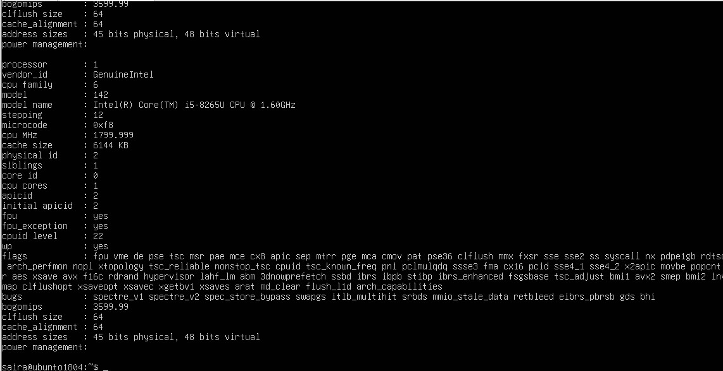
3. Memory:

free –h
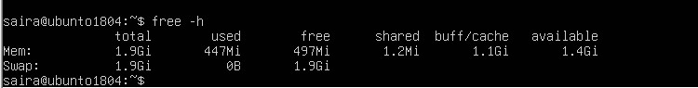
4. Disk:

df –h
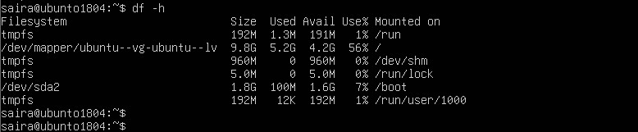
5. View OS release information:

cat /etc/os-release
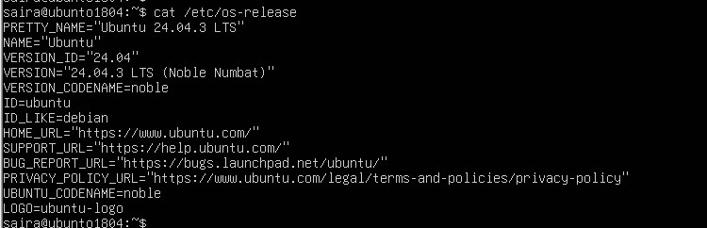
6. Processes (show top lines of ps output):

ps aux
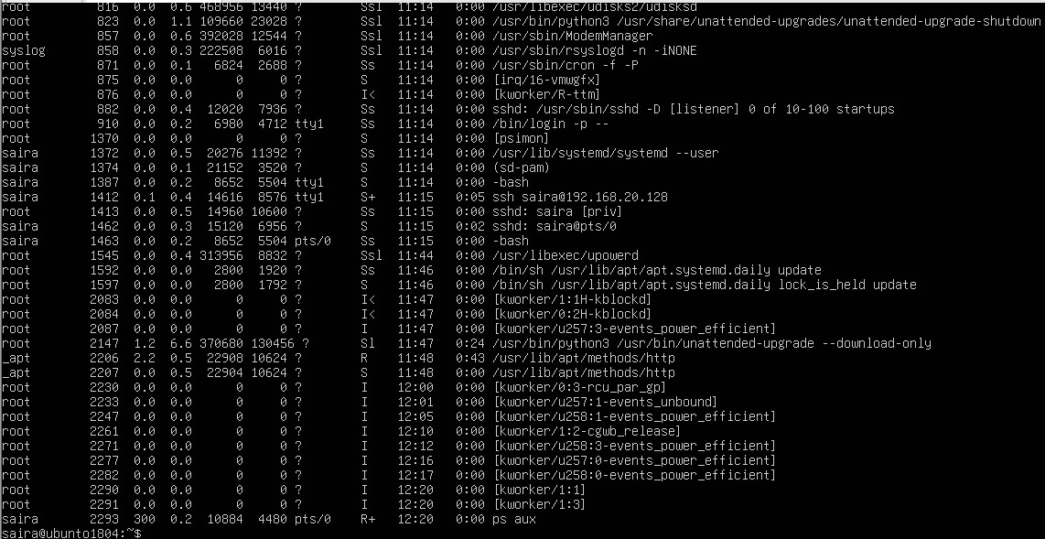

Task 6 – Users and account verification (no sudo group change)
Create a non‑root user and verify the account exists. This task does NOT add the created user to the sudo group.

Steps (inside VM terminal)
1. Create a new user named lab4user:

sudo adduser lab4user
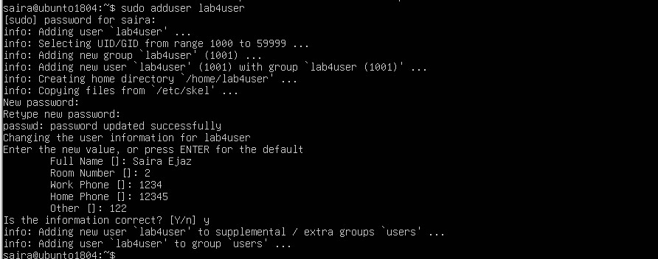
2. Verify the user entry:

getent passwd lab4user
3. Switch to the new user to verify login:

su - lab4user
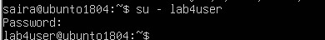
4. From the new user you may attempt a sudo command to show that sudo is not available for this account (expected failure), e.g.:

sudo whoami
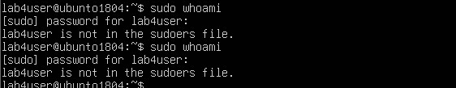
5. Return to the original user:

Exit
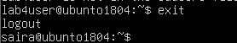
6. (Optional) Remove the test user when finished:

sudo deluser --remove-home lab4user
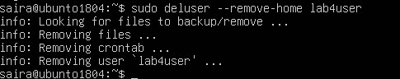

Bonus Task 7 – Create a small demo script using an editor and run it
This task is optional — complete it for extra practice or extra credit. It is not required for passing the core lab tasks.

Steps (inside VM)
1. Open an editor to create the script: nano ~/lab4/workspace/run-demo.sh
Type the following lines into the editor (manually or paste), save and exit:

#!/bin/bash
2. echo "Lab 4 demo: current user is $(whoami)"
echo "Current time: $(date)" uptime
free –h
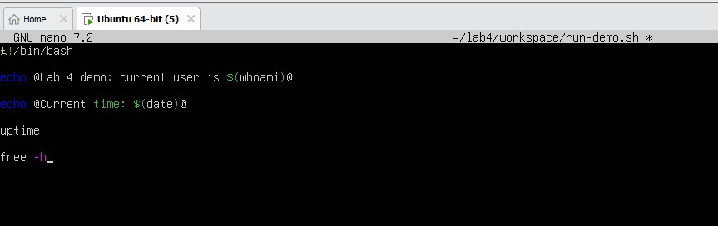
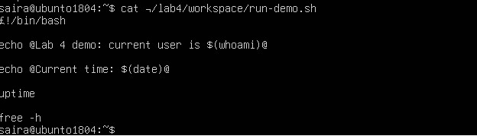

3. Make the script executable: chmod +x ~/lab4/workspace/run-demo.sh
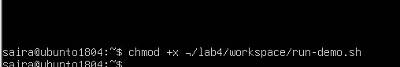
4. Run the script as your regular user:

~/lab4/workspace/run-demo.sh
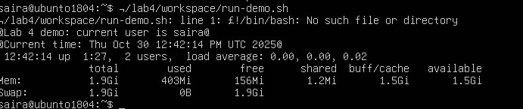

5. Optionally run it with sudo: sudo ~/lab4/workspace/run-demo.sh
